Top Ten Reasons to Purchase a Migratory Bird Hunting and Conservation Stamp

Your $15 purchase of a Migratory Bird Hunting and Conservation Stamp provides long-term benefits for birds and other wildlife and for the people who enjoy them. Since 1934, the stamps have secured over 5.5 million acres of wildlife habitat for the National Wildlife Refuge System. If you want to ensure future generations a heritage of enlightened conservation, the purchase of a stamp this year – and every year – is the best investment you can make. The stamps are beautiful, and they are essential to the lives of game and non-game species alike.

It’s time to buy and show your stamp!

All waterfowl hunters over the age of 16 are required to buy a stamp in order to hunt, but there are other compelling reasons to buy the stamp every year. Below are 10 top reasons to consider:

- There are over 560 individual National Wildlife Refuge units within the United States. Each refuge is managed as a protected haven for birds and other wildlife. Since 1934, a huge proportion of the funds used to acquire these critical habitats in the lower-48 states were provided through sales of what is today known as Migratory Bird Hunting and Conservation Stamps – commonly called “Duck Stamps.” All outdoor recreationists who enjoy wildlife and natural landscapes can thank those who have already purchased these stamps over the decades, for they have contributed over $850 million and helped to protect over 5.5 million acres of wetland and grassland habitat for wildlife and future generations of Americans.

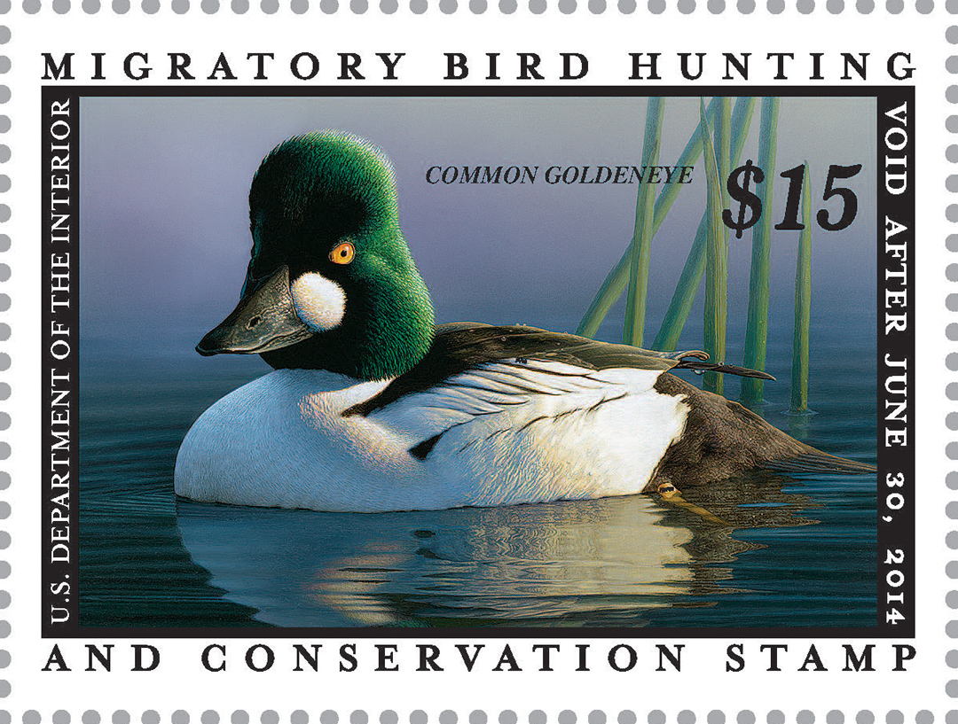
- The Stamps costs only $15 each, and it’s easy for everyone to purchase Stamps– nearly all Post Offices carry them. Stamps are extremely cost-effective: approximately 98 cents out of every dollar of a stamp price ( or $14.70) goes to land for Refuge System acquisition (direct payment and immediate related expenses). This $15-purchase is perhaps the single simplest thing you can do to support a legacy of wetland and grassland conservation for birds.

- Support small wetland acquisition. The funds not only go to refuges, but since 1958, the U.S. Fish and Wildlife Service (FWS) has used a portion of the Stamp revenues to purchase wetland and grassland habitats within the Prairie Pothole Region of the upper Midwest and northern Great Plains. Through their Small Wetlands Acquisition Program, the FWS has protected over 3 million acres of these habitats for prairie wildlife. Commonly referred to as Waterfowl Production Areas, or WPAs, they include more than 2.3 million acres in permanent easements, and over 688,000 acres in fee-title tracts of crucial habitat, a response to the draining of wetlands. All WPAs are part of the National Wildlife Refuge System. Every unit in this system provides important benefits to migratory bird species, other wildlife, water quality, aquifer replenishment, and the environment in general.

- Support grassland acquisition. In response to serious downward trends of many species of prairie nesting birds and the FWS includes permanent grassland easements in the Small Wetland Acquisition Program to conserve existing habitat for these nesting birds. Grasslands are being plowed under at a rapid rate converting these areas to crop production. Oil and gas drilling add to the prairie crisis. For example, grasslands in the Dakotas are being lost at a rate of 35 acres per hour, while conservation efforts are occurring at only 9 acres per hour. A grassland easement program driven by strong science targets the highest priority grassland areas at risk.

- The purchase of a Stamp is not something that will just benefit ducks. Among scores of other bird species, numerous kinds of shorebirds, long-legged waders, raptors, and wetland and grassland songbirds are dependent on habitat derived from Stamp purchases. (Densities of grassland bird species such as Bobolink, Grasshopper Sparrow, Clay-colored Sparrow and Sedge Wren, are remarkably higher on Refuge System grasslands than on the landscape in general.)

- You can say the same about benefits to other wildlife – not only birds – and also to water quality. Reptiles, amphibians, fish, butterflies, native plants, all flourish through Stamp investments.

- Some of the most diverse and wildlife-rich refuges in the nation have been acquired with Stamp funds. For example, see the following list of refuges and the percentage paid for through Stamp purchases.

Chase Lake in North Dakota 100.0%
Baskett Slough in Oregon 100.0%
Sacramento in California 99.6%
Bosque del Apache in New Mexico 99.2%
Pea Island in North Carolina 99.2%
Quivira in Kansas 99.1%
Muscatatuck in Indiana 98.9%
Horicon in Wisconsin 98.7%
Monomoy in Massachusetts 97.8%
Parker River in Massachusetts 97.7%
Bombay Hook in Delaware 95.2%
Santa Ana in Texas 94.9%
DeSoto in Iowa and Nebraska 90.8%
Anahuac in Texas 87.3%
Montezuma in New York 86.7%
Okefenokee in Georgia 86.2%
Laguna Atascosa in Texas 86.1%
Ottawa in Ohio 86.0%
Edwin B. Forsythe (Brigantine) in New Jersey 84.4%
Blackwater in Maryland 73.0%
Chincoteague in Virginia 69.9%

And if that isn’t enough incentive, consider that 99.8% of all WPAs in Minnesota, Iowa, North Dakota, South Dakota, and Montana were acquired through Stamp funding.

- A Stamp is a “free pass” for an entire year – for a vehicle at all refuges that charge for admission – a real bargain if ever there was one! Whatever sort of outdoor recreations you’re into – wildlife photography, birding, fishing, hunting, hiking, kayaking, or just restoring your soul in communion with nature – connecting to a National Wildlife Refuge through a stamp is a great way to do it.

- The stamp is a beautiful collectible with an associated great tradition of waterfowl art involved. It is detailed, colorful, and an accurate illustration of life.

- The Migratory Bird Hunting and Conservation [Duck] Stamp is probably the best-kept secret in all of bird conservation. And, by buying and displaying a Stamp you can show that you appreciate long-term habitat protection for all birds and other wildlife, spread the word, and show that you care!

[The above “top 10” items were compiled by the leaders of the "Friends of the Migratory Bird/Duck Stamp." Feel free to use any or all of them, to add details if you wish, and to attribute the collection to the Friends Group or not as you see fit! Don’t hesitate to copy the image of the new Stamp and use that, too! If you have space, it would be appreciated if you could include a reference or link to the website of the Friends group: www.friendsofthestamp.org ]

