OUR DUCK STAMP NEEDS NEW FRIENDS

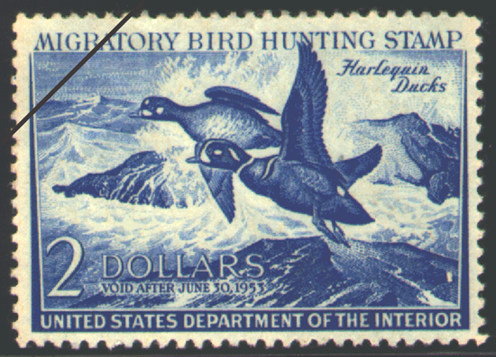
This impressive duck stamp showing two Harlequin Ducks was drawn by John H. Dick for the 1952-3 version of the stamp, and it sold almost 2.3 million copies. And at the time, the U.S. had a population of 158 million people.

Today, we in the U.S. are about double that population, about 314 million strong. But since 2000, sales of the Migratory Bird Hunting and Conservation Stamps the duck stamp have ranged between 1.4 million and 1.7 million.

Clearly, there is something wrong with this situation. More stamps need to be appreciated, and more need to be sold.

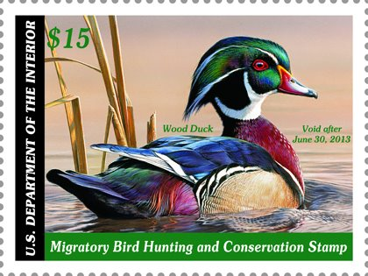
The fact that the lion’s share of the proceeds from each stamp goes to secure valuable wetland and grassland habitat for the National Wildlife Refuge System is not something that should appeal only to waterfowl hunters. The fact that already $850 million has been collected through stamp sales since 1934 should be a badge of honor for those millions of waterfowlers who have bought the stamp over the decades, but that’s not enough.

More Americans need to value this stamp, identify with this stamp, and buy this stamp.

Stamps should be important to birdwatchers, nature photographers, other hunters, hikers, canoeists, bicycle riders all sorts of people who participate in dozens of outdoor activities on our wildlife refuges. These people might not realize it, but today their visits to and use of our National Wildlife Refuge System essentially is a gift from the waterfowl hunting community.

Those non-waterfowlers should be stamp purchasers. Including them in the market expands potential sales by hundreds of thousands. And that means more valuable habitat secured in our Refuge System.

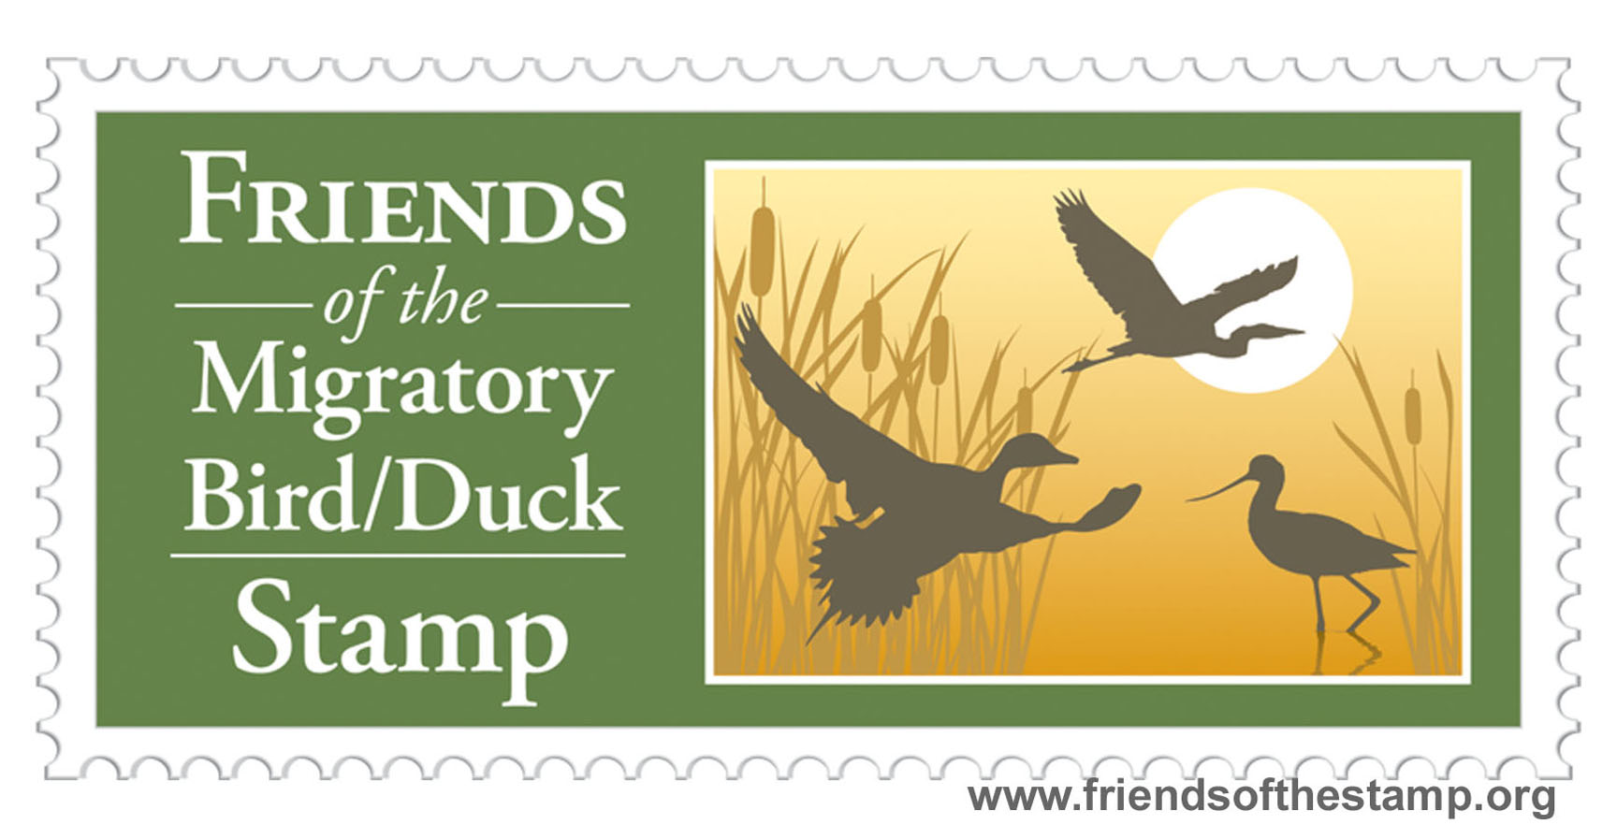
To pursue that goal a new non-profit organization has been formed: Friends of the Migratory Bird/Duck Stamp. This independent group of stamp, wildlife, and refuge enthusiasts is modeled after the very successful Friends groups that support many of our National Wildlife Refuges across the country. Our Friends group has a simple goal: to increase the appreciation and sales of duck stamp.

An information campaign by Friends of the Migratory Bird/Stamp is beginning. Every communication resource offered by the Web will be used. We have a Web site and are now being “friended” on Facebook. Much work remains to be done. If you agree that our duck stamp needs new friends, join with us!

- - - - - - - - - - - - - - - - - - - - - - - - - - - - - - - - - - - - - - - - - - - - - - - - - - - - - - - - - - - - - - - - - - - - - - - - - - - - - - - - -

Visit our website: www.friendsofthestamp.org
Fill out the form, and become an official Friend: http://tinyurl.com/stampfriends

Friends of the Migratory Bird/Duck Stamp, P.O. Box 2143, Columbia, MD 21045 or barb620@theworld.com

