OUR DUCK STAMP NEEDS NEW FRIENDS

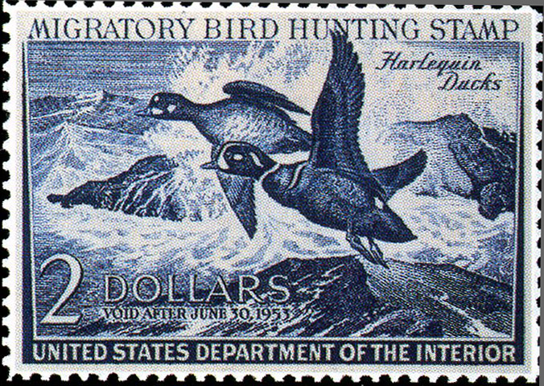
This impressive duck stamp showing two Harlequin Ducks was drawn by John H. Dick for the 1952-3 version of the stamp, and it sold almost 2.3 million copies. And at the time, the U.S. had a population of 158 million people.

Today, we in the U.S. are about double that population, about 314 million strong. But since 2000, sales of the Migratory Bird Hunting and Conservation Stamps the duck stamp have ranged between 1.4 million and 1.7 million annually.

Clearly, there is something wrong with this situation. More stamps need to be appreciated, and more need to be sold.

The fact that the lion’s share of the proceeds from each stamp goes to secure valuable wetland and grassland habitat for the National Wildlife Refuge System is not something that should appeal only to waterfowl hunters. The fact that already $850 million has been collected through stamp sales since 1934 should be a badge of honor for those millions of waterfowlers who have bought the stamp over the decades, but that’s not enough.

More Americans need to value this stamp, identify with this stamp, and buy this stamp.

Stamps should be important to birdwatchers, nature photographers, other hunters, hikers, canoeists, bicycle riders all sorts of people who participate in dozens of outdoor activities on our wildlife refuges. These people might not realize it, but today their visits to and use of our National Wildlife Refuge System essentially is a gift from the waterfowl hunting community.

Those non-waterfowlers should be stamp purchasers. Including them in the market expands potential sales by hundreds of thousands. And that means more valuable habitat secured in our Refuge System.

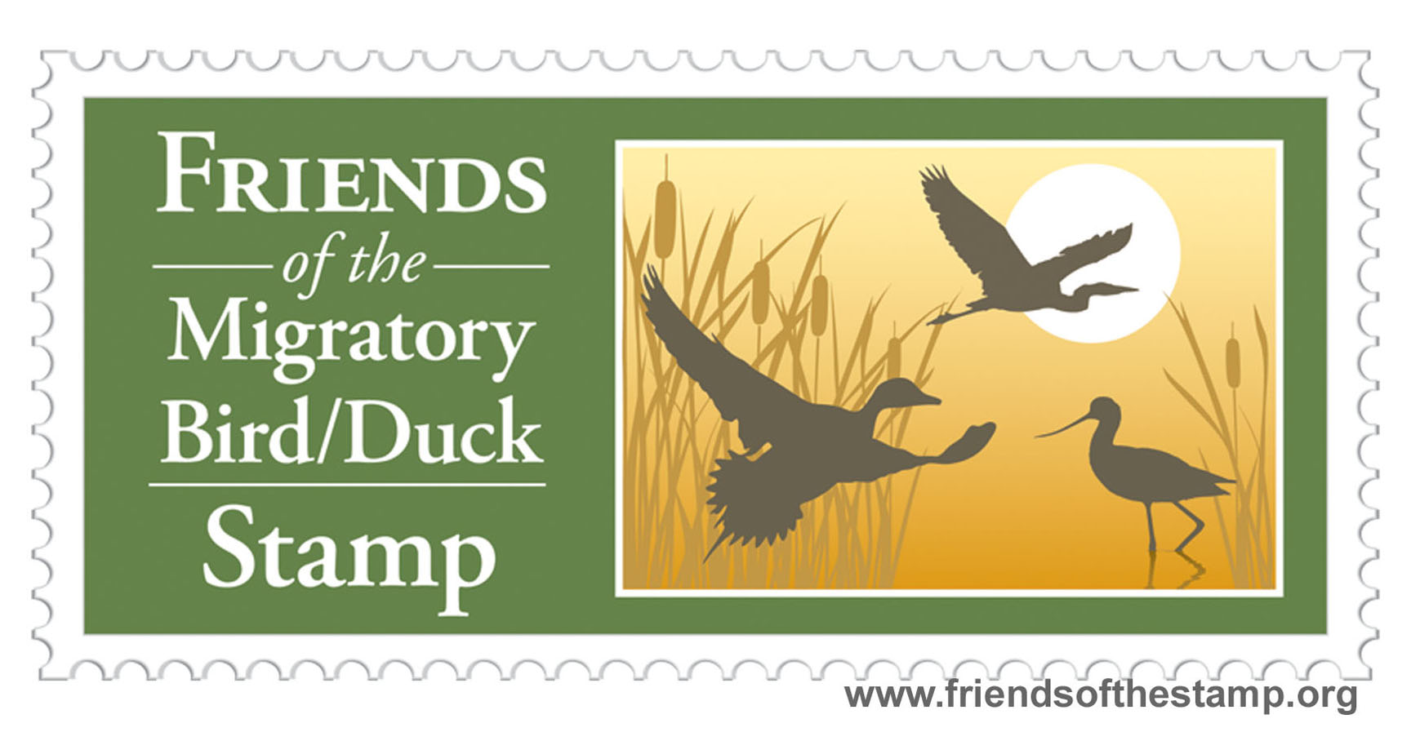
To pursue that goal, a new non-profit organization has been formed: Friends of the Migratory Bird/Duck Stamp. This independent group of stamp, wildlife, and refuge enthusiasts is modeled after the very successful Friends groups that support many of our National Wildlife Refuges across the country. Our Friends group has a simple goal: to increase the appreciation and sales of duck stamp.

An information campaign by Friends of the Migratory Bird/Stamp is beginning. Every communication resource offered by the Web will be used. We have a Web site and are now being “friended” on Facebook. Much work remains to be done. If you agree that our duck stamp needs new friends, join with us!

- - - - - - - - - - - - - - - - - - - - - - - - - - - - - - - - - - - - - - - - - - - - - - - - - - - - - - - - - - - - - - - - - - - - - - - - - - - - - - - - -

Visit our website: www.friendsofthestamp.org
Fill out the form, and become an official Friend: http://tinyurl.com/stampfriends

Friends of the Migratory Bird/Duck Stamp, P.O. Box 2143, Columbia, MD 21045 or barb620@theworld.com
WHY WE NEED A STAMP FRIENDS GROUP:

More stamps need to be appreciated, and more need to be sold.

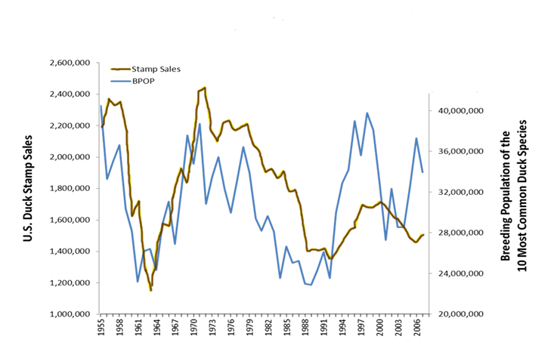
This is a chart from the recently released North American Waterfowl Management Plan (NAWMP). It shows that stamp sales (an index of duck hunter numbers) in brown were closely correlated with major duck population size in blue... at least until the mid-1990s. After this time, stamp sales - and waterfowl hunter numbers - did not rebound commensurate with waterfowl populations.

From NAWMP: “The decline in hunter numbers continues despite abundant waterfowl populations and over a decade of unprecedented hunting opportunity. U.S. waterfowl hunters have decreased 27 percent since the 1970s, and continue to decline..."

The public must also be convinced that the purchase of a stamp is not something that will benefit solely ducks. Among scores of additional bird species – numerous kinds of shorebirds, long-legged waders, and wetland and grassland songbirds – are dependent on habitat derived from stamp purchases. The same could be said about the status of other wildlife – not only birds – and water quality as benefiting from the stamp. Reptiles, amphibians, fish, butterflies, all flourish through stamp investments. Water quality is also regularly strengthened. This is a major conservation stamp!

Also poorly understood is that some of the most diverse, wildlife-rich, and popular refuges in the nation have been acquired with help from stamp funds. For example, see the following list of refuges and the percentage paid for by stamp purchases through the Migratory Bird Conservation Fund:

Sacramento in California 99.6%
Parker River in Massachusetts 99.3%
Bosque del Apache in New Mexico 99.2%
Pea Island in North Carolina 99.2%
Quivira in Kansas 99.1%
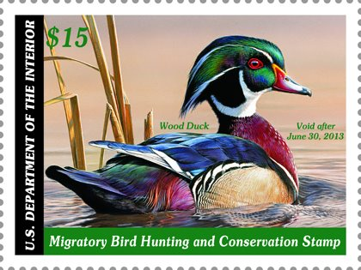
Horicon in Wisconsin 98.7%
Muscatatuck in Indiana 98.9%
Monomoy in Massachusetts 97.8%
Bombay Hook in Delaware 95.1%
Santa Ana in Texas 94.9%
DeSoto in Iowa and Nebraska 90.8%
Anahuac in Texas 87.3%
Okefenokee in Georgia 86.2%
Laguna Atascosa in Texas 86.5%
Ottawa in Ohio 86.0%
Edwin B. Forsythe (Brigantine) in New Jersey 84.6%
Blackwater in Maryland 76.6%

And if that isn’t enough incentive, consider that 99.8% of all Waterfowl Production Areas in Minnesota, Iowa, North Dakota, South Dakota, and Montana were acquired through stamp funding.

Finally, a stamp is a “free pass” for an entire year – for a vehicle full of people at all refuges that charge for admission – a real bargain if ever there was one!
- - - - - - - - - - - - - - - - - - - - - - - - - - - - - - - - - - - - - - - - - - - - - - - - - - - - - - - - - - - - - - - - - - - - - - - - - - - - - - - - - - - - - - - - - - - - - - - -

Visit our website: www.friendsofthestamp.org

